

PENGUMUMAN TRAFIK: PROJEK MASS RAPID TRANSIT (LALUAN KAJANG)
22 JUN 2026

PENUTUPAN LORONG KIRI SECARA BERKALA DI
LEBUHRAYA CHERAS - KAJANG, KUALA LUMPUR (ARAH KAJANG)

Tarikh | 28 Jun 2026 – 31 Julai 2026
Masa | 10.00 malam – 4.00 pagi
Jangka Masa | Tiga Puluh Empat (34) Hari
Tujuan | Bagi melaksanakan pemasangan tiang penghadang bunyi di atas struktur trek MRT berhampiran Stesen MRT Taman Suntex

Untuk makluman, penutupan lorong kiri di Lebuhraya Cheras - Kajang (ke arah Kajang), akan bermula pada 28 Jun 2026 hingga 31 Julai 2026. Tempoh masa kerja-kerja bermula dari pukul 10.00 malam hingga 4.00 pagi, selama tiga puluh empat (34) hari. Pelan pengurusan trafik adalah seperti berikut:

Semasa penutupan lorong kiri secara berkala sepanjang 500 meter di Lebuhraya Cheras – Kajang (ke arah Kajang) dilaksanakan, pengguna jalan raya akan dilencongkan ke lorong kanan untuk meneruskan perjalanan ke arah Kajang.

Pengguna jalan raya dinasihatkan untuk mematuhi arahan papan tanda trafik dan pengawal trafik yang bertugas. Untuk maklumat lanjut, sila rujuk peta di bawah.

- Baki halaman ini telah dibiarkan kosong dengan sengaja -

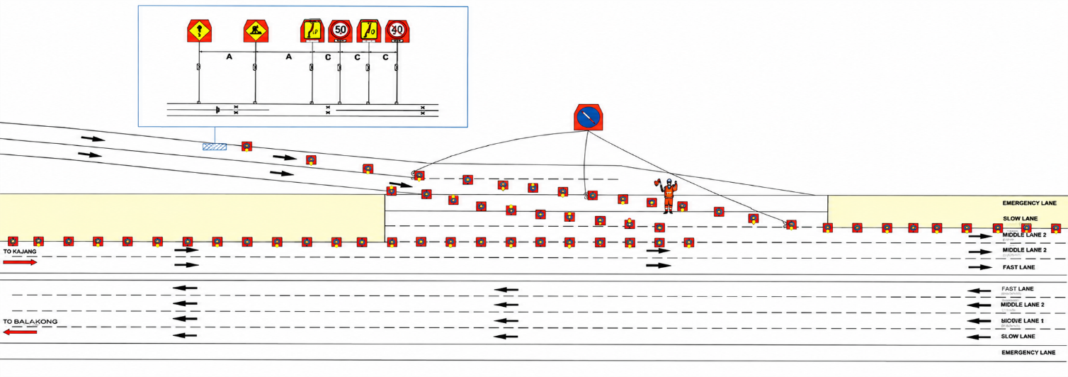
LEBUHRAYA CHERAS – KAJANG KM13 – KM13.3

DARI JALAN CHERAS
SUSUR MASUK KE CKE

LEBUHRAYA CHERAS – KAJANG KM13.3 – KM13.5

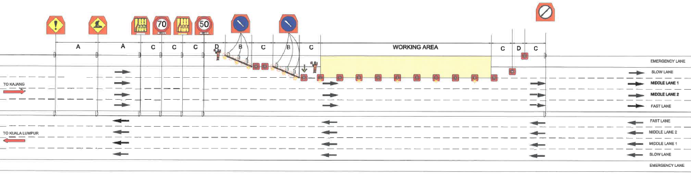

PETA: PENUTUPAN LORONG KIRI LEBUHRAYA CHERAS – KAJANG (LEBUHRAYA GRAND SAGA) KM13 – KM13.5, KUALA LUMPUR (ARAH KE KAJANG)

Untuk maklumat lanjut, sila hubungi:

Muhibbah Engineering (M) Bhd.
Wan Azuhairi Wan Ibrahim
Pengurus Projek
Tel.: +6011-11911108 E-mel: wnazuhairi.msi@muhibbah.com.my

Malaysia Rapid Transit Corporation Sdn Bhd
Mohammad Hazwan Hilmi Mohammad Tajul Urus
Divisyen Aset dan Nilai Tambahan Teknikal
Tel.: +603 2081 3000 E-mel: hazwanhilmi.tajul@mymrt.com.my

Malaysia Rapid Transit Corporation Sdn Bhd
Tingkat 5, Menara I&P 1
No. 46 Jalan Dungun, Bukit Damansara
50490 Kuala Lumpur, Malaysia
MRTCareline: 1800 88 6782
E-mel: feedback@mymrt.com.my

TRAFFIC ANNOUNCEMENT: MASS RAPID TRANSIT PROJECT (KAJANG LINE)
22 JUNE 2026

INTERMITTENT LEFT LANE CLOSURE AT
CHERAS – KAJANG EXPRESSWAY, KUALA LUMPUR (TOWARDS KAJANG)

Date | 28 June 2026 – 31 July 2026
Time | 10.00 PM – 4.00 AM
Duration | Thirty four (34) Days
Reason | To carry out the installation of noise barrier columns on the MRT track structure near MRT Taman Suntex Station.

Please be informed that the closure of the left lane on the Cheras–Kajang Highway (towards Kajang) will commence from 28 June 2026 until 31 July 2026. The works will be carried out from 10:00 PM to 4:00 AM for a period of thirty-four (34) days. The Traffic Management Plan is as follows:
During the intermittent closure of the left lane along a 500-meter stretch of the Cheras–Kajang Highway (towards Kajang), road users will be diverted to the right lane to continue their journey towards Kajang.
Road users are advised to comply with all traffic signs and follow the instructions of traffic controllers on duty.
For further information, please refer to the map below.

- The rest of this page has been intentionally left blank -

LEBUHRAYA CHERAS – KAJANG KM13 – KM13.3
LEBUHRAYA CHERAS – KAJANG KM13.3 – KM13.5

FROM JALAN CHERAS
ENTRY SLIP ROAD TO CKE

MAP: LEFT LANE CLOSURE ON THE CHERAS–KAJANG HIGHWAY (GRAND SAGA EXPRESSWAY), KM13 – KM13.5, KUALA LUMPUR (TOWARDS KAJANG)

For further information, please contact:

Muhibbah Engineering (M) Bhd.
Wan Azuhairi Wan Ibrahim
Project Manager
Tel: +6011 1191 1108 Email: wnazuhairi.msi@muhibbah.com.my

Malaysia Rapid Transit Corporation Sdn Bhd
Mohammad Hazwan Hilmi Mohammad Tajul Urus
Asset dan Technical Value Add Division
Tel: +603 2081 3000 Email: hazwanhilmi.tajul@mymrt.com.my

Malaysia Rapid Transit Corporation Sdn Bhd
Level 5, Menara I&P 1
46 Jalan Dungun, Bukit Damansara
50490 Kuala Lumpur, Malaysia
MRTCareline: 1800 88 6782
Email: feedback@mymrt.com.my

