
TRAFFIC ANNOUNCEMENT
TEMPORARY ONE NIGHT ONLY EXTENSION OF LONG-TERM NIGHT ROAD CLOSURE OF SURIAN UNDERPASS (KOTA DAMANSARA-BOUND & LDP-BOUND)
4 APRIL 2015

Date | 4 April 2015 – 5 April 2015
Time | 11:00 pm to 10:00 am
Duration | 11 Hours
Reason | To facilitate paving and milling works of Surian Underpass

Please be informed that there will be a temporary, one night only extension of the long-term night road closure of Surian Underpass (Kota Damansara-bound & LDP-bound). It will be implemented starting 4th April 2015 – 5th April 2015 from 11:00 pm to 10:00am.

During this closure, motorists are advised to follow these diversions:
- Motorists from LDP Highway wanting to use the Surian Underpass to go to Kota Damansara
Motorists will be diverted to use the lanes next to the Underpass (as indicated in PURPLE arrow)

- Motorists from Kota Damansara wanting to use the Surian Underpass to go to LDP-Highway
Motorists will use the lanes next to the Underpass and head towards the PJU 7/1 traffic light intersection (as indicated in GREEN arrow)

This extension is necessary as to carry out works to improve the condition of Surian Underpass for motorists.

The long-term night closure of the Surian Underpass on both bounds (Kota Damansara-bound and LDP- bound) along Persiaran Surian will continue as planned until 6 June 2015 from 12:00 midnight to 6:00am, intermittently.

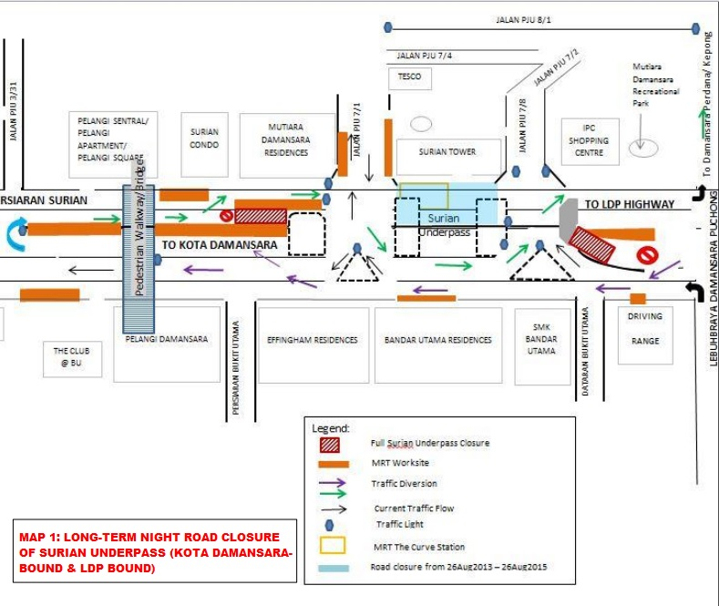

For media enquiries, please contact
Adeline De Cruz Tel: +6012 217 2017 adeline@mudajaya.com
Siti Fadzillah Ismail Tel: +603 7493 3963 sitifadzillah@mgjv-kvmrt.com.my
MMC GAMUDA KVMRT (PDP) SDN BHD (927050-H)
Block A, Level 7, Menara Mustapha Kamal, PJ Trade Centre, No 8, Jalan PJU 8/8A,
Bandar Damansara Perdana, 47820 Petaling Jaya, Selangor, Malaysia
T: 603 7494 2200 F: 603 7722 2643 www.kvmrt.com.my

